EXP NO: 06 Linux Server Forensics NAME : ADHIYAN PERIYAR R P

DATE: 14/08/2025 ROLL NO : 231901002

AIM:

Learn about digital forensics artefacts found on Linux servers by analysing a compromised server

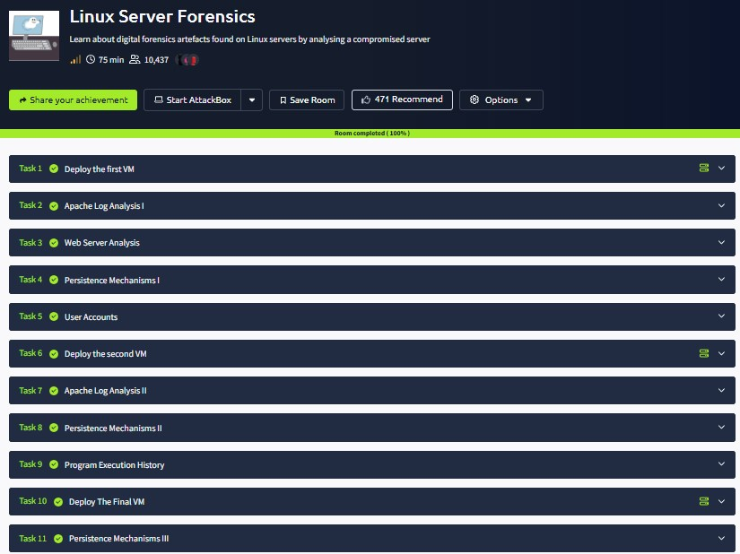

Task 1 : Deploy the first VM

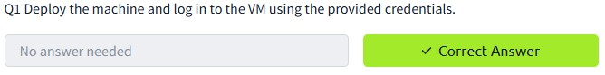

Task 2 : Apache Log Analysis I

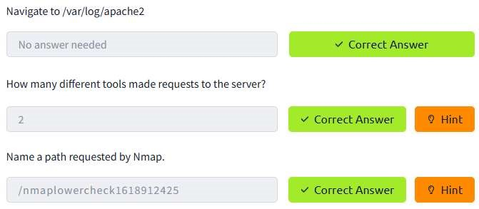

Task 3 : Web Server Analysis

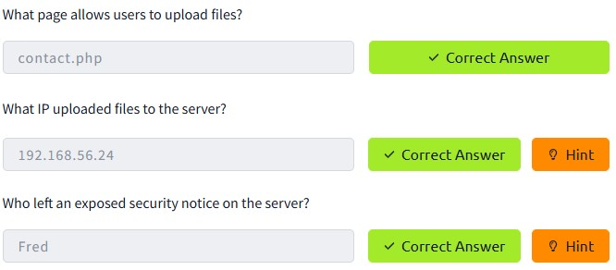

Task 4 : Persistence Mechanisms I

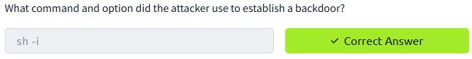

Task 5 : User Accounts

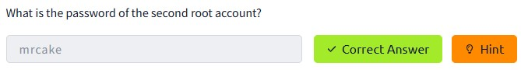

Task 6 : Deploy the second VM

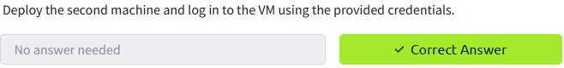

Task 7 : Apache Log Analysis II

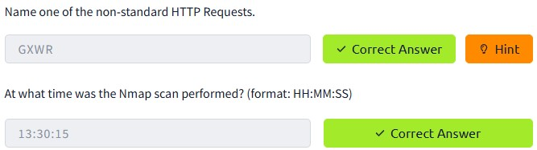

Task 8 : Persistence Mechanisms II

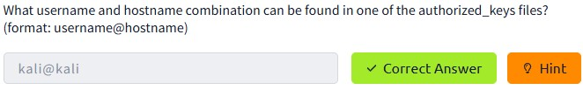

Task 9 : Program Execution History

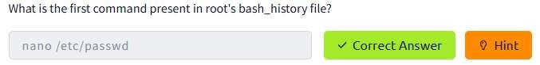

Task 10 : Deploy The Final VM

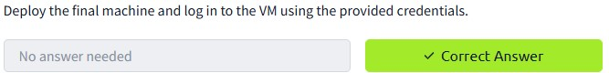

Task 11 : Persistence Mechanisms III

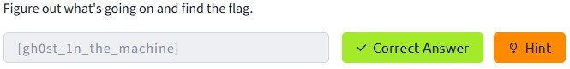

RESULT :

Linux Server Forensics is successfully completed in tryhackme platform.